**MID-TERM EXAM**

**FUNDAMENTALS OF LOGIC/INTRODUCTION TO LOGIC  
PHIL 1**

**Date: 20.10.2020**

**Name: Dmitry Beresnev**

**Student ID: d.beresnev@innopolis.university**

**SECTION 1**

**EXERCISES**

**(up to 30 marks, 6 questions for 5 marks each).**

**1.** Consider the following argument:

If you buy the jumbo popcorn, then you will need a large drink. You bought the jumbo popcorn. You will need a large drink.

What syllogism? Write your answer here and explain why:

**Modus Ponens (T)**

1. If you buy the jumbo popcorn, then you will need a large drink
2. You bought the jumbo popcorn
3. You will need a large drink

**Because it has following structure:**

1. If P then Q
2. P
3. Therefore, Q

**2.**Consider the following argument:

If you get the bon bons, you won’t need popcorn. Ruslan needed popcorn. So, he did not get the bon bons.

What syllogism? Write your answer here and explain why:

**Modus Tollens (T)**

1. If you get the bon bons, you won’t need popcorn
2. Ruslan needed popcorn
3. He did not get the bon bons

**Because it has following structure:**

1. If P then Q
2. Not Q
3. Therefore, not P

**3.** Consider the following argument:

Anyone who plays the piano well must have done a lot of practice. Yuja has done a lot of practice. Therefore, she plays the piano well.

What syllogism? Write your answer here and explain why:

**Modus Ponens (T)**

1. If you have done a lot of practice, you plays the piano well
2. Yuja has done a lot of practice
3. Therefore, she plays the piano well

**Because it has following structure:**

1. If P then Q
2. P
3. Therefore, Q

**4.** If a valid argument has a false conclusion, then at least one premise must be false

Is this true or false?Write your answer here and explain why:

**True**

Because argument is valid when it is impossible to have all premises true and conclusion is false. Therefore, valid argument has a false conclusion, iff it has at least one false premise.

**5.** If an invalid argument has all true premises, then the conclusion must be false

Is this true or false?Write your answer here and explain why:

**False**

Because validity of arguments is about connections between premisses and conclusion, not about their truthfulness.

**6. Open Theoretical Question (answer no more no less than ½ A4 page)**Explain the Differences between Stoic Logic and Categorical Logic. Then reflect on the importance of Stoic Logic for the development of Propositional Logic. What are the differences/similarities between them?

***Differences:***

**Stoics** claimed that Logic is a part of Philosophy, while Aristotle (father of **Categorical Logic)** claimed that it is a mere tool.  
Key features of **Stoics**: Ataraxia and Virtues  
Key feature of **Categorical logic:** Copula and Quantifiers

**Stoic** logic was based on the analysis of propositions, not terms

**Categorical logic** was based on analysis of relationships, between categorical propositions.

***Stoic Logic and Propositional Logic:***

Stoic logic concentrated not on terms, but on assertible. Assertibles can be expanded with connectives: Conditional(if), Conjunctive (and) and Disjunctive (or). Leibnitz (father of Propositional logic) bring concepts of Stoics and improved them. So, Propositional logic refers to the meaning of claim more than to the connections between terms. As Stoic Logic, Propositional one is more natural tool for evaluating validity and truth than Categorical logic. Therefore, the Stoics played key role in Propositional logic development.

***Similarities of Stoic Logic and Propositional Logic:***

Both concentrate on actual truthfulness and validity of proposition

Both uses special logic connectives

***Differences between Stoic Logic and Propositional Logic:***

Propositional logic doesn’t have such key features of Stoic Logic as ataraxia and virtues.

Stoics had only 3 connectives: Conditional(if), Conjunctive (and) and Disjunctive (or). While Propositional logic has 5 connectives: Conjunctive (•), Disjunctive (⋁), Negation (~), Implication (⊃) and Equivalence (≡).

**SECTION 2**

**EXERCISES (explain the answers when needed)**

**(up to 50 marks, 10 questions for 5 marks each)**

**True or False? Then explain why?**

**7.** An invalid deductive argument could have all true statements in it.  
Is this true or false?

**True**Once again, validity of deductive argument is not about truthfulness of its premises and conclusion. Therefore, an invalid deductive argument could have all true statements in it.

**8**. Consider the following argument:

You will meet a tall, handsome stranger or you will stay home and pick fleas off of your cat. You didn’t meet a tall, handsome stranger. Therefore, you stayed home and picked fleas off of your cat.

A. Invalid, Disjunctive Syllogism

B. Valid Disjunctive Syllogism

C. Invalid, Modus Ponens

D. Valid, Modus Tollen

E. Invalid, Affirming the Consequent

Write your answer here: **B**

**9.** Consider the following argument:  
If the lever is depressed then the valve will open, provided the pressure in the boiler is over 500 psi and the temperature exceeds 80C. The pressure right now is 600 psi. The gauge, which is extremely reliable, reads 90C. So if the valve won’t open then the level isn’t depressed.

Which of the following is true?

1. If we accept the basic premises then we should accept the final conclusion as a certainty.
2. If we accept the basic premises and we have no further information, then we should accept the final conclusion.
3. The argument contains a fallacy.
4. The whole argument is inductive.
5. None of the above.

Write your answer here **A**

**10. Venn Diagram the following Statement and say what sort of statement it is**

1. ‘’Some Humans are not Women’’

***Sort: O***

***Diagram:***

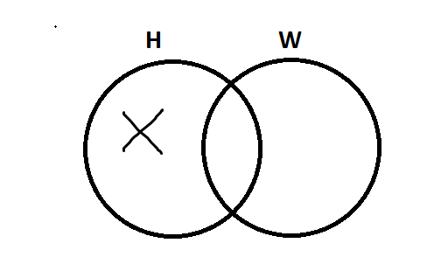

**11. Using Venn Diagrams and Square of Opposition Determine whether the inference is conditionally valid, unconditionally valid, invalid or logically unknown.**

1. ‘’It is false that all students are geniuses’
2. ‘’Therefore, no students are geniuses’’

~A ⊃ E. These sorts (A and E) are contraries (according to the Square of Opposition), so when we negate A we got E. But these propositions are universal, so it is ***conditionally valid.***

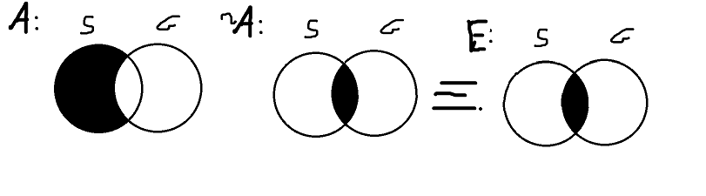

**12. Rephrase the following statement in standard categorical proposition. Individuate subject, predicate, copula and quantifier. Then say which term (If any) gets distributed**

1. “I will eat all toppings except anchovies on my pizza’’

Some toppings on pizza are not food I like

**S:** toppings on pizza

**P:** food I like

**Copula:** are not

**Quantifier:** some

**Distribution:** Predicate

**13. Rephrase the following statement in standard categorical proposition. Individuate subject, predicate, copula and quantifier. Then say which term (If any) gets distributed**

1. ‘’No one except my friends are allowed to borrow my car’’

No people who are not my friends are people who can borrow my car

**S:** people who are not my friends

**P:** people who can borrow my car

**Copula:** are

**Quantifier:** no

**Distribution:** Both

**14. Determine the main operator in the following proposition. Then determine its truth values. Let *A*, *B*, and *C* be true and *X*, *Y*, and *Z* be false. Circle your answers.**

∼[(*A* ≡ *X* ) ⋁ (*Z* ≡ *Y* )] ⋁ [(∼*Y* ⊃ *B*) (*Z* ⊃ *C* )]



***Main operator:*** ⋁ (Disjunction)

Proposition is ***True***

**15**. **Determine the main operator in the following proposition. Then determine its truth values. Let *A*, *B*, and *C* be true and *X*, *Y*, and *Z* be false. Circle your answers.**

(*Z* ⊃ *C* ) ⊃ {[(∼*X* ⊃ *B*) ⊃ (*C* ⊃ *Y* )] ≡ [(*Z* ⊃ *X* ) ⊃ (∼*Y* ⊃ *Z* )]}

***Main operator:*** ⊃ (Implication)

Proposition is ***True***

**SECTION 3**

**DIAGRAMMING (20 marks)**

**16.** For 20 marks, **define** the 4 types of reasoning involved in diagramming and give one example for each type.

**Then** individuate premises/conclusion of the following diagram. **Finally**, diagram the following passage

‘I know of two reasons for being hopeful that the global economy will improve. First of all, since the Chinese and Indian economies are booming, demand for goods from all over the world will increase, and so considerable growth in international trade may be expected. But a different reason is this: the political situation in America is much better now, which means that American confidence will increase; and we know that increased American confidence will improve the global economy. My feeling, however, is that both of these reasons are poor. For one, there is no clear relation between the demand for goods and growth in international trade because many nations take protectionist measures to ensure that the demand for goods can be locally met. Moreover, the state of American politics is not as rosy as the media would have us believe. Besides, an upbeat political situation would not increase American confidence anyway because the fundamentals of the American economy remain weak’.

1. **Serial reasoning**  
   *Example*:  
   1) I have a cat and dogs  
   2) Therefore, I pet some animals  
   3) So, I have extra money and time to spend on animals  
   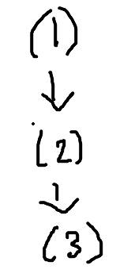
2. **Divergent reasoning**  
   *Example*:  
   1) Today is my free day  
   2) I can go for I walk  
   3) I can stay at home  
   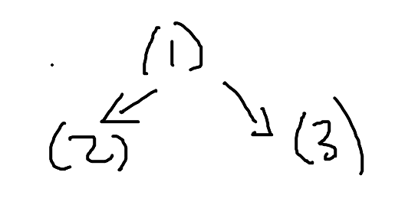
3. **Linked reasoning**  
   *Example*:  
   1) I like apples or pears  
   2) I do not like apples  
   3) So, I like pears  
   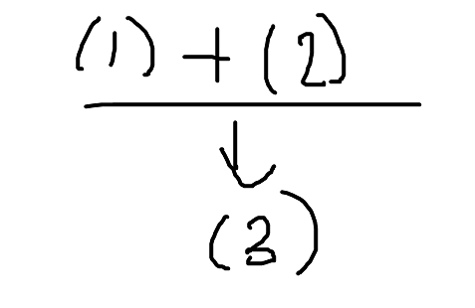
4. **Convergent reasoning**  
   *Example*:  
   1) Today is sunny day  
   2) Sunglasses looks cool  
   3) So, it is good idea to wear sunglasses today  
   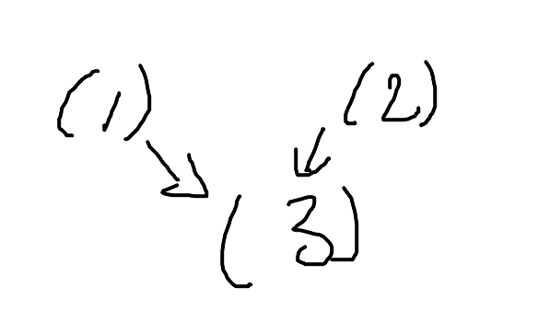

‘I know of two reasons for being hopeful that the (6) global economy will improve. First of all, since the (1) Chinese and Indian economies are booming, (2) demand for goods from all over the world will increase, and so considerable (3) growth in international trade may be expected. But a different reason is this: the (4) political situation in America is much better now, which means that (5) American confidence will increase; and we know that increased American confidence will improve the global economy. My feeling, however, is (12) that both of these reasons are poor. For one, (8) there is no clear relation between the demand for goods and growth in international trade because (7) many nations take protectionist measures to ensure that the demand for goods can be locally met. Moreover, (9) the state of American politics is not as rosy as the media would have us believe. Besides, an (11) upbeat political situation would not increase American confidence anyway because the (10) fundamentals of the American economy remain weak’.

***Premises:***

1. Chinese and Indian economies are booming
2. demand for goods from all over the world will increase
3. growth in international trade
4. political situation in America is much better now
5. American confidence will increase
6. the global economy will improve
7. many nations take protectionist measures to ensure that the demand for goods can be locally met
8. there is no clear relation between the demand for goods and growth in international trade
9. the state of American politics is not as rosy as the media would have us believe
10. fundamentals of the American economy remain weak’
11. upbeat political situation would not increase American confidence anyway
12. both of these reasons (3) and (5) are poor

**Conclusion: ~(6) :** global economy will NOT improve

***Diagram:*  
  
